Table of Contents

1. Objective 3

2. Scope 3

3. Pharmaceutical Information 3

4. Product Description 4

4.1 Mix (Intermediate) Information 4

4.2 Finished Drug Product Information 4

5. Gelnique 10% Manufacturing Process Overview 6

5.1 Manufacturing Process Overview 6

5.2 Mixing Process 7

5.3 Packaging 9

6. References 11

**List of Tables**

Table 1: Oxybutynin Chloride Gel, 100 mg/g Mix Composition (Item # 175547) 4

Table 2: Packaging Components of Gelnique 10% 5

Table 3: Gelnique 10% Manufacturing Unit Operations 7

**List of Figures**

Figure 1: Oxybutynin Chloride Structure (CAS 1508-65-2) 3

Figure 2: Sachet Artwork for Gelnique 10% 5

Figure 3: Carton Artwork for Gelnique 10% 6

Figure 4: Process Flow Diagram of Mixing Process 8

Figure 5: Process Flow Diagram of Packaging: FFS and Cartoning 10

**List of Abbreviations**

|  |  |
| --- | --- |
| CQA: | Critical Quality Attribute |
| CMA: | Critical Material Attribute |
| QTPP: | Quality Target Product Profile |
| N/A: | Not Applicable |
| DS: | Drug Substance |
| DP: | Drug Product |
| IPT: | In-Process Testing |
| MS: | Material Specification |
| NLT: | Not Less Than |
| NMT: | Not More Than |
| CPP: | Critical Process Parameters |
| Mins: | Minutes |
| RPM: | Revolutions per Minute |
| ICH: | International Conference on Harmonization |
| CFR: | Code of Federal Regulations |
| USP: | United States Pharmacopeia |
| NF: | National Formulary |
| EP: | European Pharmacopeia |
| API: | Active Pharmaceutical Ingredient |
| QS: | Quantity Sufficient |
| OEL: | Occupational Exposure Limit |
| OHC: | Occupational Health Category |
| AQL: | Acceptable Quality Level |
| OOS: | Out of Specification |
| OOT: | Out of Trend |
| RPN: | Risk Priority Number |
| PHA: | Potential Hazard Analysis |
| SBRE: | Statistical Based Risk Evaluation |
| HI: | Hazard Identification |
| EDMS: | Electronic Document Management System |
| QA: | Quality Assurance |
| SOP: | Standard Operating Procedure |
| BOM: | Bill of Materials |
| ERP: | Enterprise Resource Planning |
| EH&S: | Environmental Health and Safety |
| IPC: | In-Process Controls |
| CS: | Control Strategy |
| Min: | Minimum |
|  |  |
|  |  |
|  |  |

# Objective

The objective of this report is to provide product and process information for Gelnique™ (Oxybutynin Chloride) Gel 10%.

# Scope

This report covers the product pharmaceutical information, product description, drug composition, and the manufacturing process flow.

# Pharmaceutical Information

Oxybutynin Chloride is the active pharmaceutical ingredient in Gelnique 10%.

Figure 1: Oxybutynin Chloride Structure (CAS 1508-65-2)

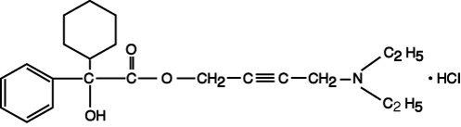

|  |  |
| --- | --- |
| Chemical Name | 4-(diethylamino)but-2-ynyl 2-cyclohexyl-2-hydroxy-2phenylacetate;hydrochloride |
| Molecular Formula | C22H32ClNO3 |
| Molecular Weight | 393.952 g/mol |
| Appearance | White crystalline powder |
| Mechanism Description | The compound is an anticholinergic, antispasmodic agent indicated for the treatment of overactive bladder. The drug substance (DS) exerts an antispasmodic action on smooth muscle tissue and inhibits the muscarinic action acetylcholine on smooth muscle. Therefore, DS help decrease the urge and frequency of incontinent episodes and voluntary urination by relaxation of the detrusor muscle. |
| Melting Point | 129 – 130°C |
| Solubility | Water and acids, practically insoluble in alkali |
| pKa | 8.04 |
| Log P (*n*-octanol/water) | 2.9 (pH 6) |
| Reference: The Merck Index, 13th edition; P 1245 | |

# Product Description

Gelnique™ (Oxybutynin Chloride) Gel 10% is a clear and colorless hydro-alcoholic gel packaged in unit-dose sachet. The target fill of the drug product is 1 g (1.14 mL). The contents of one sachet of Gelnique™ should be applied once daily to dry, intact skin on the abdomen, upper arms/shoulders or thighs. Application sites should be rotated, do not apply Gelnique on the same site on consecutive days.

## **Mix (Intermediate) Information**

Gelnique 10% consists of the following ingredients: Oxybutynin Chloride, USP, Purified Water, USP/EP, Sodium Hydroxide, NF/EP, Alcohol Ethanol USP, Glycerin, USP / Glycerol, EP and Hydroxypropyl Cellulose, NF. The composition of the mix and function of each ingredient is provided in the table below.

| Table 1: Oxybutynin Chloride Gel, 100 mg/g Mix Composition (Item # 175547) | | | | |
| --- | --- | --- | --- | --- |
| **Component** | **Function** | **Item Number** | **Batch Quantity**  **(kg)** | **Mix Ratio**  **(w/w %)** |
| Oxybutynin Chloride, USP | API | 175037 | 33.16 | 10.0 |
| Purified Water, USP/EP | Solvent | Plant System | 44.64 | 13.5 |
| Sodium Hydroxide, NF/EP | Buffering Agent | 175025 | 0.786 | 0.2 |
| Alcohol Ethanol USP | Solvent | 175039 | 243.05 | 73.3 |
| Glycerin, USP / Glycerol, EP | Emollient | 175024 | 3.32 | 1.0 |
| Hydroxypropyl Cellulose NF | Gelling Agent | 175038 | 6.63 | 2.0 |
| **Total** | | | 331.6 | 100.0 |

## **Finished Drug Product Information**

The bulk drug product is filled into a 1 g unit-dose sachet. Gelnique 10% comes in four packaging configuration based on amount per carton and distribution location, the item # and amount per carton and location is listed below.

* Item 52544008430 – Gelnique Oxybutynin Chloride Gel, 10%, Ctn x 30 (US)
* Item 52544008477 – Gelnique Oxybutynin Chloride Gel, 10%, Ctn x 7 (Sample, US)
* Item 74028708430 – Gelnique Oxybutynin Chloride Gel, 10%, Carton x 30 (Canada)
* Item 74028708477 – Gelnique Oxybutynin Chloride Gel, 10%, Carton x 7, Sample (Canada)

Actavis is commercially approved to manufacture all four configurations but currently only manufactures 30 units per carton configuration for US and Canada market. However, packaging configuration has no impact on finished drug product quality. Therefore, PRACS will be applied to all finished drug product configuration. The packaging components for finished drug product are provided in the table below.

| **Table 2: Packaging Components of Gelnique 10%** | | | |
| --- | --- | --- | --- |
| **Component** | **Function** | **Gelnique 10%,**  **30 units per Carton, US**  **(Item # 52544008430)** | **Gelnique 10%,**  **30 units per Carton, Canada**  **(Item # 74028708430)** |
| **Item Number** | |
| Oxybutynin Chloride Gel, 100 mg/g | Mix | 175547 | |
| Sachet Material | Primary Packaging | 208371 | 233173 |
| Carton (30 units) | Secondary packaging | 198150 | 227458 |
| Gelnqiue 10% Insert | Physician / Patient Insert | 232849 | 220149 |
| Shipper Box | Tertiary Packaging | 174665 | 174665 |
| Shipper Label | Drug Product Label | 52544008430 (01) | 74028708430 (01) |

As discussed earlier, the bulk drug product is filled in a unit-dose sachet package. The artwork of the sachet package is shown below.

Figure 2: Sachet Artwork for Gelnique 10%

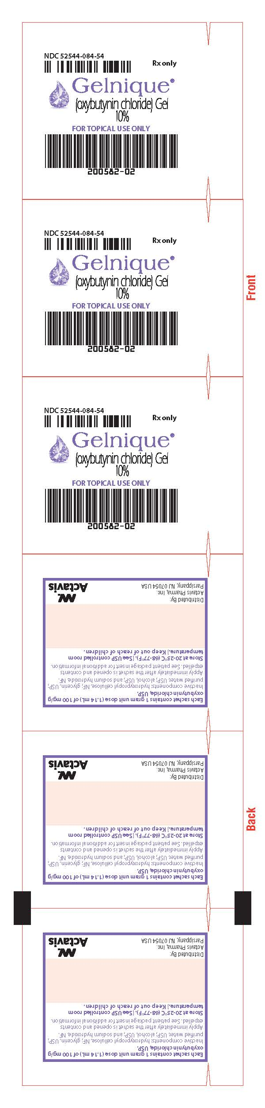

**Back Front**

Thirty sachets packages are placed in a carton with a physician / patient insert; the artwork of the carton is shown in the figure below.

Figure 3: Carton Artwork for Gelnique 10%

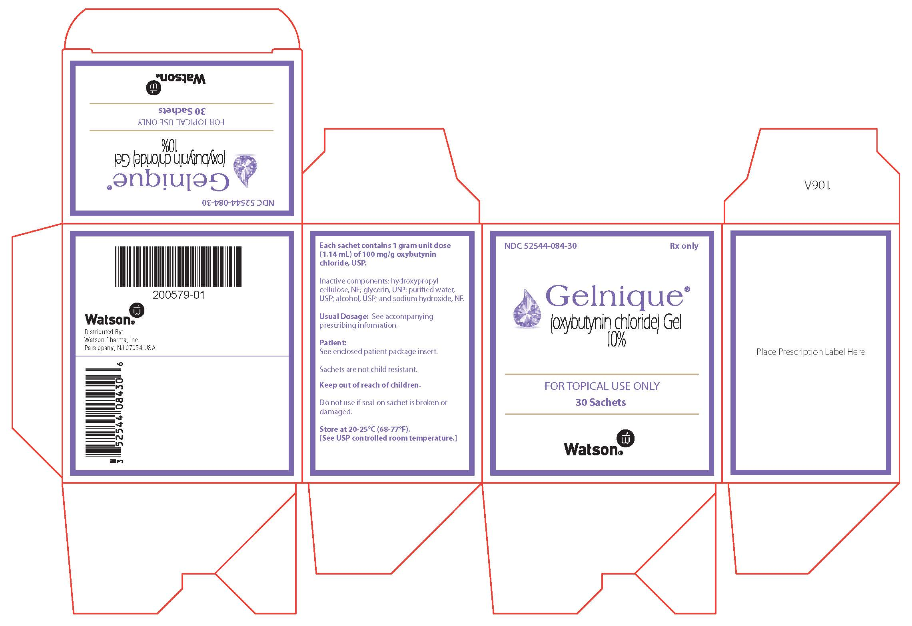

# Gelnique 10% Manufacturing Process Overview

## **Manufacturing Process Overview**

There are two main unit operations in the production of Gelnique™ (Oxybutynin Chloride) Gel 10%;

* Mixing – Oxybutynin Chloride Gel, 100 mg/g
* Packaging – Form/Fill/Seal (FFS) and Cartoning

Item number associated with each unit operation is provided in the table below.

| Table 3: Gelnique 10% Manufacturing Unit Operations | | |
| --- | --- | --- |
| **Product Strength**  **(w/w)** | **Operation and Item Number(s)** | |
| **Mixing** | **Packaging** |
| 100 mg / g | 175547 | 52544008430 (US only) |
| 74028708430 (Canada only) |

## **Mixing Process**

The mixing process of Gelnique 10% consists of two phase; side phase and main phase. Any appropriately size container is adequate for preparing the side phase and ROSS PVM-100 is used to mix the main phase.

**Side Phase:**

1. Add predefined amount of Purified Water, USP/EP and Sodium Hydroxide NF/EP in a side phase container. Manual agitation is initiated to thoroughly mix the Sodium Hydroxide, NE/EP pellets in Purified Water, USP/EP. Continue manually mixing the side phase until all pellets have completely dissolved.
2. Hold on to the Purified Water/Sodium Hydroxide solution until the completion of Hydroxypropyl Cellulose, NF in the main phase.

**Main Phase:**

1. Add predefine amount of Alcohol Ethanol, USP, Oxybutynin Chloride, USP and Glycerin USP / Glycerol, EP in the main phase mixer (ROSS PVM-100). The disperser blade is engaged for a specified period of mixing time at predetermined temperature range.
2. Hydroxypropyl Cellulose, NF is added slowly in the main phase mixer with a predefined addition time. The disperser blade and anchor blade are engaged for a specified period of mixing time.
3. Transfer Purified Water/Sodium Hydroxide solution into the main phase mixer. The disperser blade and anchor blade are engaged. Vacuum pressure is pulled on the bulk drug product after the completion of transfer and it mixed for a predetermined amount of time.
4. Upon completion of previous mixing step, turn off the disperser blade and continue mixing with anchor blade for a specified amount of time. Upon completion of mixing time, turn the vacuum off.
5. Transfer the bulk drug product from main phase mixer into transfer vessels.

Figure 4: Process Flow Diagram of Mixing Process



## **Packaging**

Gelnique 10% is a clear, colorless, hydroalcoholic gel containing 100 mg/g oxybutynin chloride. Gelnique 10% gel is packaged in 1g unit dose sachets. Gelnique 10% 1 g sachets are formed, filled, and sealed using the Mediseal LA-160. The form/fill/seal (FFS) manufacturing process is described below

1. Lot information is printed onto the sachet material as it is unrolled on the Mediseal LA160. The printed lot information (lot number and expiration date) is electronically verified.
2. A single roll of 12” sachet material is slit down the center separating the front and back portions.
3. The sealant sides of the front and back portions are brought together and drawn into the seal, fill, and cut stations.
4. The seal, fill, and cut stations work together simultaneously at different locations on the web. Each of these stations appear downstream as listed below:
   1. The heat sealing station seals the outer edges of the sachets, separating the 6” web into three 2” lanes. The heat sealing station also seals the bottom of the sachets that will be filled next and the top of the sachets that were just filled.
   2. The gel is pumped through dispensing nozzles into the three lanes of three-sided sachets. The target fill-weight is 1.03g (range 0.96 – 1.10g).
   3. The cooling station cools the heat-sealed regions of the filled sachets.
   4. The tear tab station punches tear notches into the sachets.
   5. The slitting blades at the longitudinal cutting station separates the three lanes of filled sachets
   6. The shear station, or transversal cutting station, cuts the final 2”x2.5” sachets from the web.
5. The completed sachets are picked and placed onto a conveyor belt for secondary packaging.

Sachets are sampled for in-process testing prior to secondary packaging. In-process testing of the sachet FFS process includes machine speed verification, visual inspections, burst testing (seal integrity test), and sachet fill-weight tests.

Figure 5: Process Flow Diagram of Packaging: FFS and Cartoning



# References

| **Document Type** | **Document Name** | **Document #** |
| --- | --- | --- |
| USP Monograph | Oxybutynin Chloride Monograph | USP 31 |
| Technical Report | Oxybutynin Chloride Topical Gel Formulation Development / Technology Transfer Report | TR-8709-27 |